Rare Beauty Brands wants to have us build a script to automatically generate the invoices, but there is a consideration of selecting the appropriate AR Account based on the currency.

What we will need to do is create a custom record that will be used as a mapping table of Currency to AR Account.

We will then need a scheduled script that will run to generate the invoices and select the appropriate AR Account based on the currency on the invoice.

Currency field on the invoice.

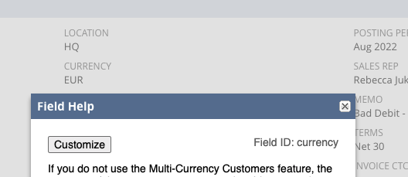

AR Account on the Invoice

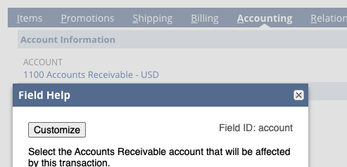

Custom table will have two fields:

* Currency: List field type with the list being Currency Codes.
* AR Account: List field with list being GL Accounts.

Script will select orders pending billing and create invoices with the appropriate AR Account based on the currency.